Relationship between population ageing and economic growth
Introduction：
The purpose of this study is to discuss the impact of population aging on socio-economic growth.Main hypothesis is that as the population ages, the supply of labor in the labor market will decrease, which will lead to a decrease in the workforce in the society, which will have a negative impact on socio-economic growth.
Data Description：
The data for this study was collected from the the United States census bureau website on the age of the U.S. population, the macrotrends website on GDP, and the PMC website. For methodology, I used Descriptive Statistics and hypothesis test.
Descriptive Statistics：

The distribution map based on the statistics in the United States census bureau Age-Sex Pyramid for the United States shows the distribution of age groups in the United States for the last census (figure 1.). The graph covers the distribution of males and females from age 0 to 80. The entire distribution is roughly pyramidal in shape, with a wider base indicating a larger younger population, which decreases in size as age increases. In terms of distribution by age group, the young population is from 0 to 18 years old, which is a larger age group and indicates a higher birth rate. The elderly population is 60 years and above, and the gradual increase in the population in this age group clearly shows the trend of aging.

In terms of the ratio of men to women, the number of males and females varies across the age groups. Particularly in the older age groups, the proportion of females is relatively high, reflecting the fact that, broadly speaking, females usually have a longer life expectancy than males. Therefore, according to the 2020 census, the proportion of older people is also increasing, despite the fact that there is a larger proportion of younger people.

According to the United States census bureau “U.S. Older Population Grew From 2010 to 2020 at Fastest Rate Since 1880 to 1890” (figure 2.). The chart shows the number of people aged 65 and older in the United States (in millions) and their percentage of the total population between 1920 and 2020. As can be seen from the chart, the number of people aged 65 and over has continued to grow since 1920, increasing from about 7 million to more than 54 million, showing a significant upward trend.Especially, the growth rate has accelerated at the beginning of the 21st century, reflecting the intensification of an aging society: the percentage of the elderly population is likely to continue to increase in the future as the birth rate declines and life expectancy increases.
According to macrotrends website for U.S. GDP 1960-2024 statistics. The chart (figure 3.) shows the changes in U.S. GDP between 1960 and 2020 in terms of total and per capita GDP, as well as annual percentage changes. The GDP per capita perspective also shows a significant increase in per capita GDP, reflecting an increase in per capita economic levels. But economic growth from 2010 to 2020 becomes flat compared to other periods. The labor market may face challenges as the proportion of the population aged 65 and above increases. The increase in the elderly population could lead to labor shortages, which could affect the potential for economic growth.
Analysis：
I used a hypothesis test to show the relationship between the two factors. The data searched in the graph (figure 4.) Finally, the correlation coefficient = -0.0358, which is a negative correlation with a p-value < 0.05. That is to say, population aging has a negative impact on economic growth to a certain extent but not to a great extent. It is not very big. The factor of economic growth is caused by a combination of external factors.
Conclusion：
Using the population aged 55-60 as a proxy for population ageing for statistical and computational purposes, the study shows that population ageing does have a negative impact on economic growth. However, the actual impact is not significant.
Reference：
Jonathan cylus, lynn al tayara. (2021, August). Health, an Ageing Labour Force, and the Economy: Does Health Moderate the Relationship between Population Age-Structure and Economic Growth? PMC. https://pmc.ncbi.nlm.nih.gov/articles/PMC8505790/#sec8
Appendix:
Figure 1.
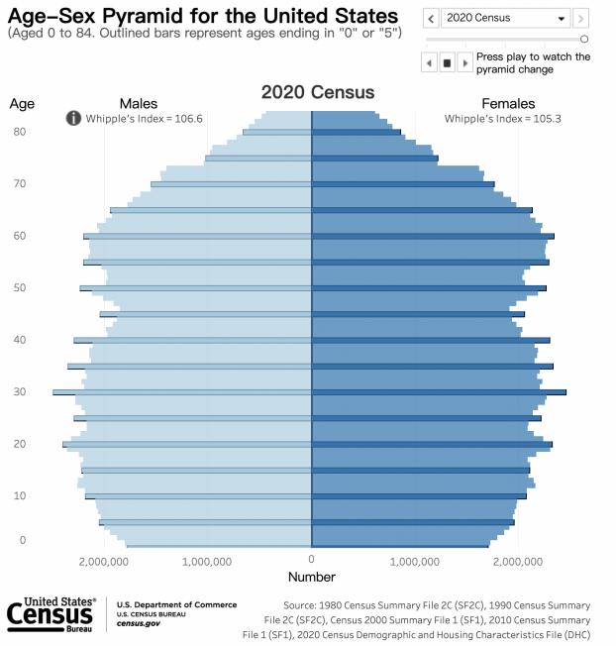
Figure 2.
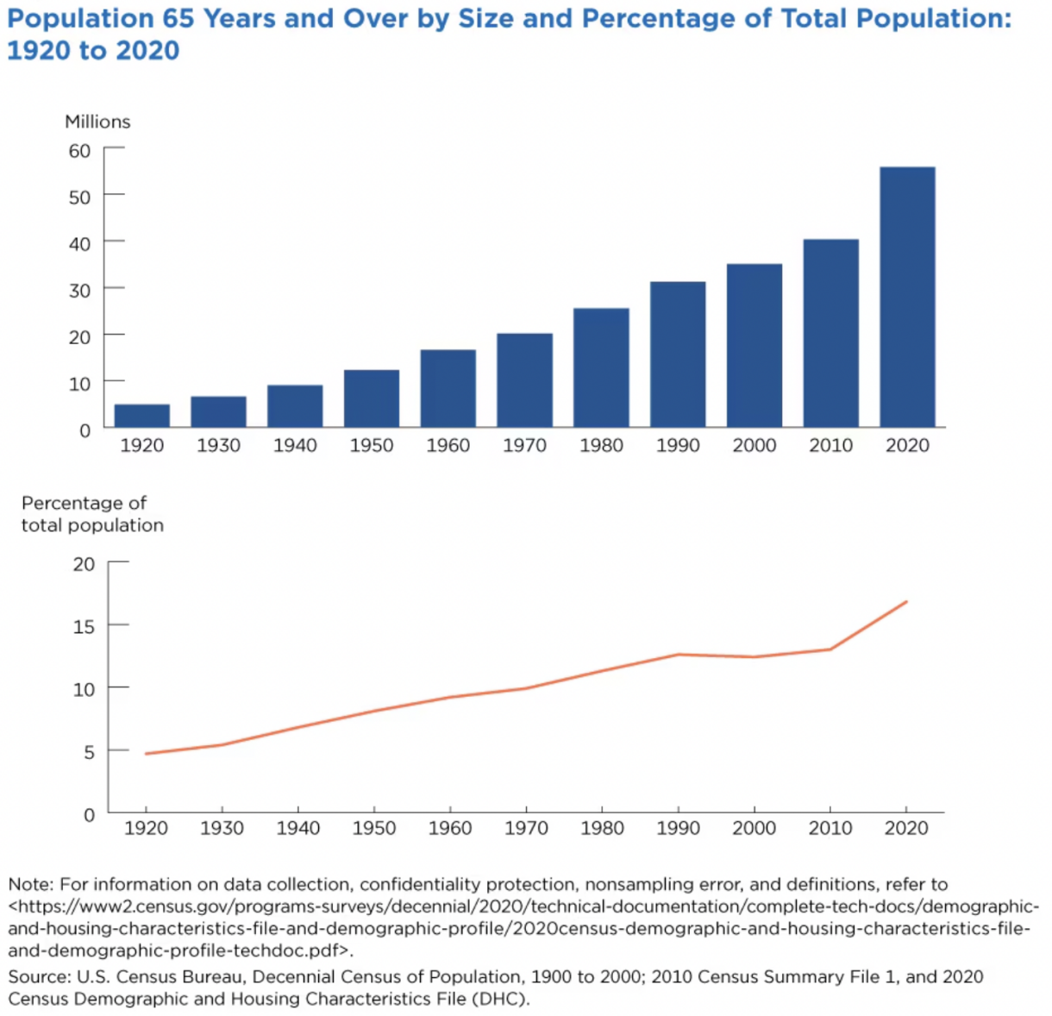
Figure 3.
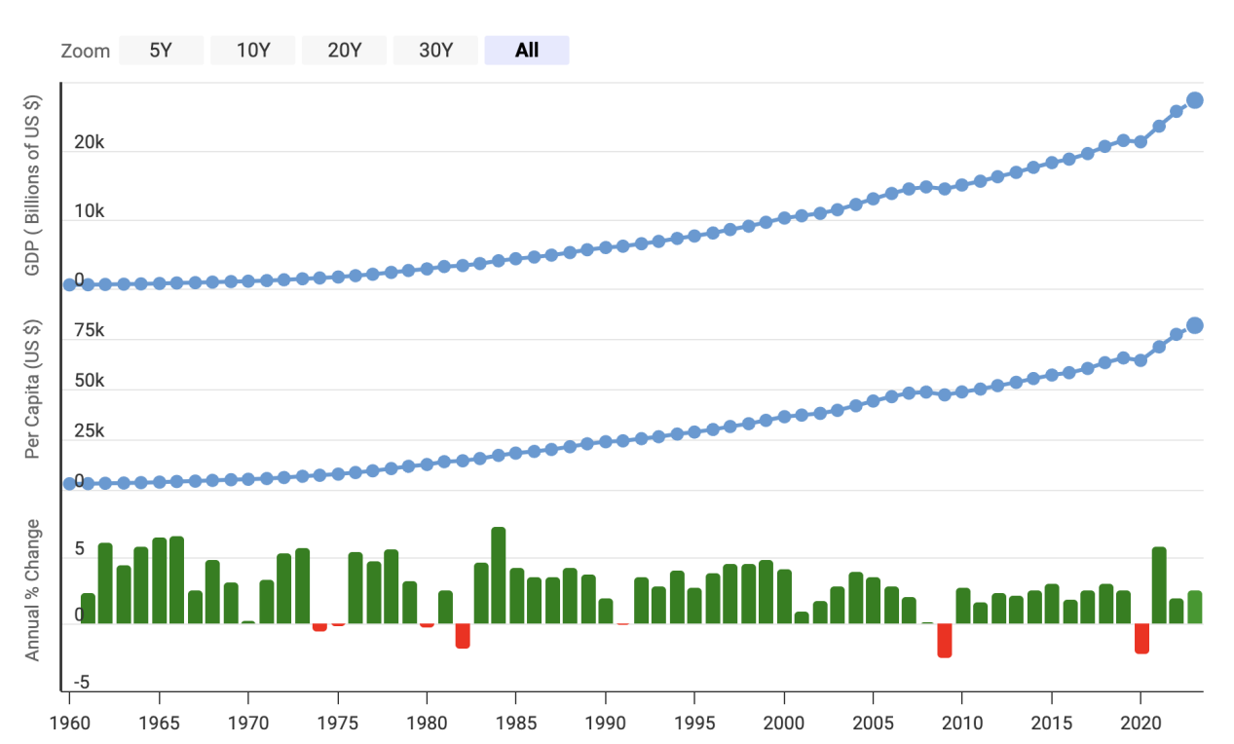
Figure 4.
